# Track

## Definition:

**# Source**: **Chatgpt (GPT-5-Standard) at [10/26/2025]**  
A **track** is an individual **recorded piece of music**. It can be **vocal, instrumental, or a combination** and is usually part of a larger collection, like an album or playlist.

## 🎶 Key Features:

**# Source**: **Chatgpt (GPT-5-Standard) at [10/26/2025]**

* Can be a **song** with lyrics or an **instrumental piece**.
* Often labeled as **Track 1, Track 2, etc.** on albums or digital releases.
* Can be **streamed, downloaded, or played** individually.
* Can exist as a **single track** (standalone) or part of an **album/playlist**.

## 🎵 Examples:

**# Source**: **Chatgpt (GPT-5-Standard) at [10/26/2025]**

* *“Thriller”* on Michael Jackson’s **Thriller album** — one track.
* *“Imagine”* by John Lennon — a single track.
* An **instrumental piano piece** released on Spotify as a track.

## 🧭 In Short:

**# Source**: **Chatgpt (GPT-5-Standard) at [10/26/2025]**

**Track** = A **single piece of recorded music**, either standalone or part of a collection like an album.

**Track** = a **basic unit of music** — it’s general and flexible, and can belong to **many categories** depending on how it’s presented or performed.

## Difference Between Track, Song, and Single

**# Source**: **Chatgpt (GPT-5-Standard) at [10/26/2025]**

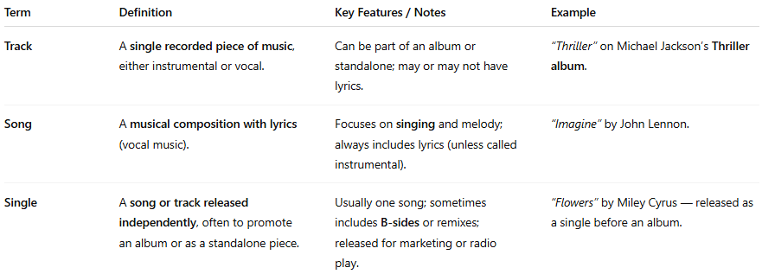

| **Term** | **Definition** | **Key Features / Notes** | **Example** |
| --- | --- | --- | --- |
| **Track** | A **single recorded piece of music**, either instrumental or vocal. | Can be part of an album or standalone; may or may not have lyrics. | *“Thriller”* on Michael Jackson’s **Thriller album**. |
| **Song** | A **musical composition with lyrics** (vocal music). | Focuses on **singing** and melody; always includes lyrics (unless called instrumental). | *“Imagine”* by John Lennon. |
| **Single** | A **song or track released independently**, often to promote an album or as a standalone piece. | Usually one song; sometimes includes **B-sides** or remixes; released for marketing or radio play. | *“Flowers”* by Miley Cyrus — released as a single before an album. |

**In Short:**

* **Track** = Any individual piece of recorded music (vocal or instrumental).
* **Song** = Track that has **lyrics**.
* **Single** = Track or song **released separately**, often to promote an album.

💡 **Tip:**  
A **single** is always a **track**, a **song** can be a track, but not all tracks are songs (instrumentals are tracks but not songs).